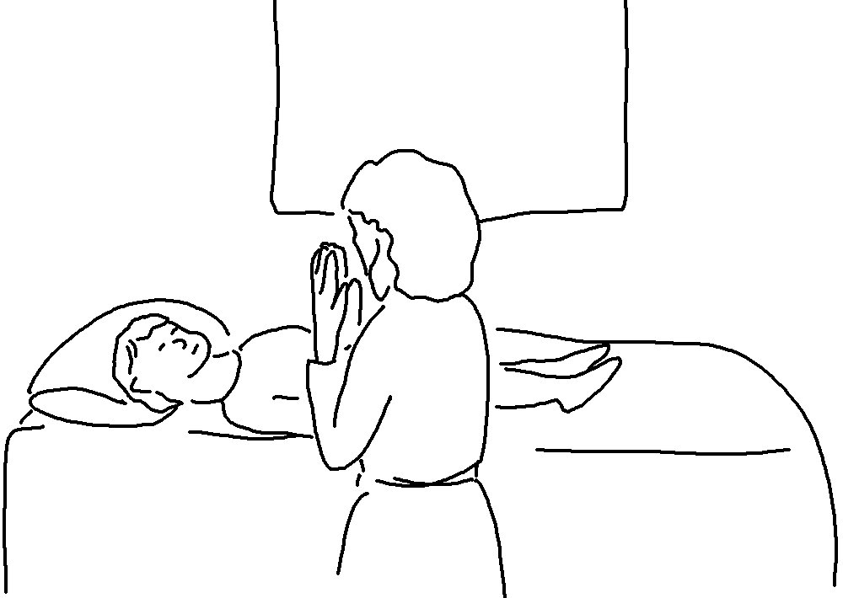
Matthew 6:8_{NLT}
Your Father knows exactly what you _ _ _ _ even before you _ _ _ Him!

